**Course Two Week Four: Pivot Activity Instructions**

Open the file contained within the folder name shown above.

Create a pivot table of the property portfolio to show:

* The asking price as the value field;
* The type of property in the rows;
* The location in the columns;
* The remaining fields in the filter area.

Change the filters and aggregate functions to show a **count** of properties that have:

* 3 bedrooms;
* A medium garden; and
* 2 bathrooms.

Your pivot table should look something like this:

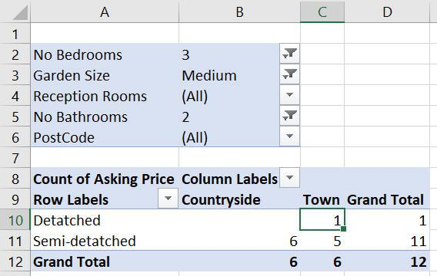

*Use the filters at the top to only show the data you are interested in.*

There is only one property that is detached and location town - use drill down to show this:

Drill down

*Double-click on cell****C10****to see the property details.*

Change your pivot table so that it now shows the **average asking price** of houses with:

* The postcode of the property in the rows;
* The type of property in the columns; and
* The remaining fields in the filter area.

*Double-click on any property price to see the full details.*

Use **Save As...** to save the file in your own new Excel work folder.